ARTIFICIAL INTELLIGENT
CSA1712
Lab experiment
Name:S.Lekha
Regno:192511104
6.Question: Write the python program for Vacuum Cleaner problem.
Aim: To write a Python program to implement the Vacuum Cleaner problem using state-space search.
Program:
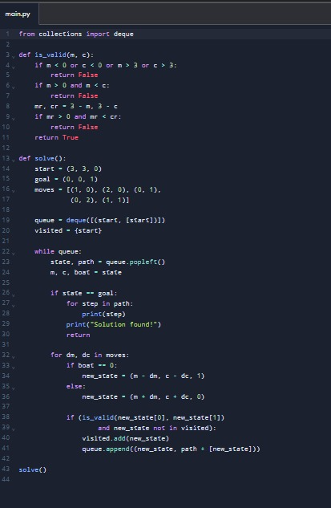

Output:
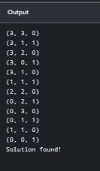

Program 7 — Breadth-First Search (BFS)
Question: Write the python program to implement BFS.
Aim: To implement Breadth-First Search (BFS) to traverse a graph level by level using a queue.
Program:
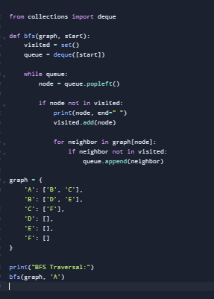
Output:
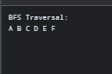

Program 8 — Depth-First Search (DFS)
Question: Write the python program to implement DFS.
Aim: To implement Depth-First Search (DFS) to traverse a graph by exploring one path as deeply as possible before backtracking.
Program:
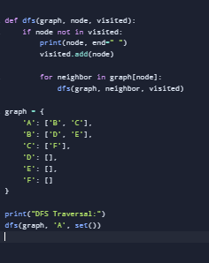
Output:
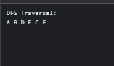

Program 9 — Travelling Salesman Problem
Question: Write the python to implement Travelling Salesman Problem.
Aim: To write a Python program to find the minimum-cost tour that visits every city exactly once and returns to the starting city.
Program:
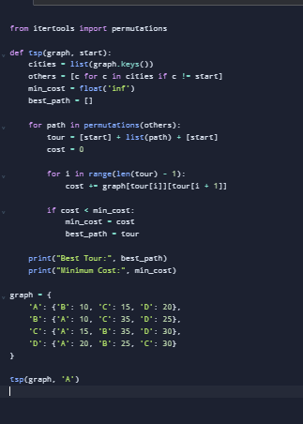
Output:
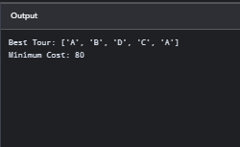

Program 10 — A* Algorithm
Question: Write the python program to implement A* algorithm.
Aim: To implement the A* search algorithm to find the shortest path from a start node to a goal node using path cost and heuristic estimates.
Program:
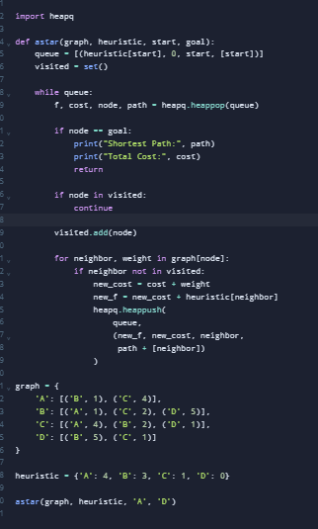
Output:
